

SIMATS ENGINEERING
Saveetha Institute of Medical and Technical Sciences
Chennai 2026
ASSESSMENT TOOL -2
CO2_AT2

Name : P Giriprasad Reddy
Register No : 192525172
Course code : CSA1016
Course name: Software Engineering
Faculty name: Anitadavamani K

Architecture Design Assignment
SafeRoute AI: Intelligent Road Hazard Detection and Accident Prevention System

1. Analyze System Requirements

1.1 System Objectives
The primary objective of the SafeRoute AI system is to improve road safety by detecting hazards in real time and providing immediate alerts to drivers. The system uses Artificial Intelligence, Computer Vision, and Cloud Computing to identify dangerous road conditions such as potholes, road cracks, fallen trees, waterlogging, animals, and unexpected obstacles. The system helps drivers avoid accidents by providing timely warnings and safer route recommendations.

1.2 Functional Requirements
- User registration and secure login.
- Capture live road images through the vehicle camera.
- Process images using OpenCV.
- Detect road hazards using the YOLO AI model.
- Identify different types of road obstacles.
- Store hazard information in the cloud database.
- Send voice and push notifications to drivers.
- Display hazard locations through map services.
- Generate reports and analytics for administrators.
- Predict accident-prone areas using historical data.

1.3 Non-Functional Requirements
- High detection accuracy.
- Real-time response.
- Secure authentication.
- High availability (24×7).
- Easy maintenance.
- Scalable cloud infrastructure.
- Reliable data storage.
- Fast system performance.

1.4 Quality Attributes
Attribute | Description
Scalability | Supports increasing users and vehicles.
Performance | Detects hazards with minimal delay.
Reliability | Provides accurate and continuous monitoring.
Availability | Operates continuously without interruption.
Security | Protects user data through authentication and encryption.
Maintainability | Individual services can be updated independently.

2. Selection of Software Architecture

Selected Architecture
Hybrid Architecture (Layered + Microservices Architecture)

Justification
A Hybrid Architecture combines the advantages of Layered and Microservices architectures. The presentation layer provides user interaction through mobile applications and dashboards. The API Gateway manages communication between the client and backend services. Independent microservices handle user management, AI detection, notifications, and map services. This architecture improves scalability, maintainability, security, and system performance.

Advantages
- Modular development.
- Independent deployment of services.
- Easy maintenance.
- Better scalability.
- Faster development.
- Improved fault isolation.
- Supports cloud deployment.
3. Software Architecture Diagram
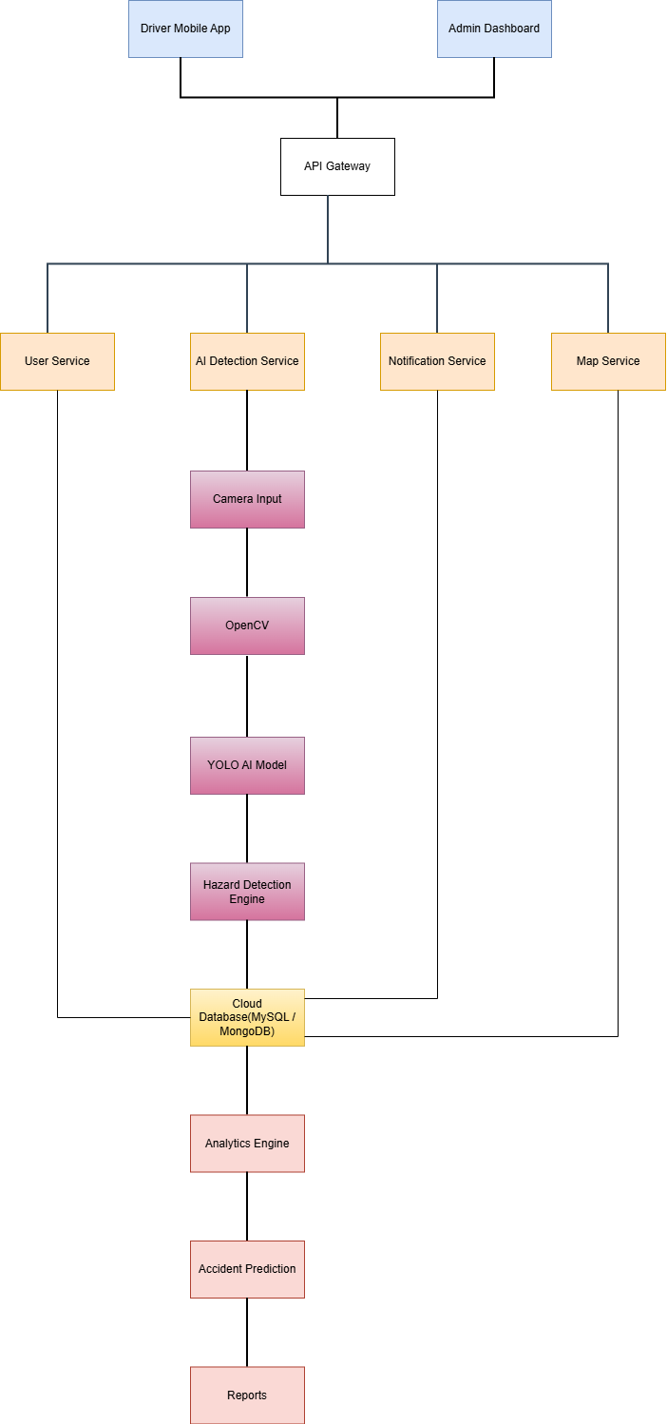
Fig 1:Software Architecture of SafeRoute AI System
4. Component Description and Interaction

Driver Mobile Application
The Driver Mobile Application is the primary interface used by drivers. It displays live hazard alerts, safe navigation routes, and accident warnings. Drivers receive voice and push notifications whenever hazards are detected.

Admin Dashboard
The Admin Dashboard enables administrators to monitor system performance, view hazard reports, manage users, and analyze accident statistics.

API Gateway
The API Gateway receives requests from both the mobile application and the admin dashboard. It routes requests to the appropriate backend services while handling authentication and request management.

User Service
The User Service manages user registration, authentication, profile management, and user information stored in the database.

AI Detection Service
The AI Detection Service receives images from the vehicle camera and processes them using OpenCV and the YOLO AI model to identify road hazards accurately.

Notification Service
This service sends real-time alerts to drivers using voice notifications and push messages whenever a hazard is detected.

Map Service
The Map Service displays the exact location of detected hazards and suggests safer alternative routes.

Camera Input
The vehicle camera continuously captures live road images for processing.

OpenCV
OpenCV performs image preprocessing, including resizing, filtering, and noise reduction before the AI model analyzes the images.

YOLO AI Model
The YOLO (You Only Look Once) model performs real-time object detection by identifying potholes, obstacles, animals, damaged roads, and other hazards.

Hazard Detection Engine
This component verifies detected hazards and forwards validated hazard information to the database and notification service.

Cloud Database
The Cloud Database stores user details, hazard locations, GPS coordinates, reports, and system logs.

Analytics Engine
The Analytics Engine analyzes stored hazard data to identify accident-prone areas and generate statistical reports.

Accident Prediction
This module predicts future accident risks using historical hazard information and AI analysis.

Reports
The reporting module generates daily, weekly, and monthly reports for administrators and government authorities.

5. Workflow of the System
- The driver starts the SafeRoute AI application.
- The vehicle camera continuously captures road images.
- Images are sent to the AI Detection Service.
- OpenCV preprocesses the captured images.
- The YOLO AI model detects road hazards.
- The Hazard Detection Engine validates the detected hazards.
- Hazard information is stored in the Cloud Database.
- The Notification Service immediately alerts the driver.
- The Map Service displays the hazard location and recommends safer routes.
- The Analytics Engine analyzes stored data.
- Accident Prediction identifies high-risk areas.
- Reports are generated and displayed on the Admin Dashboard.

6. Quality Attribute Analysis

Scalability
The system uses microservices, allowing each service to scale independently. As the number of users increases, additional service instances can be deployed without affecting the entire system.
Security
Authentication, encrypted communication, and secure cloud storage protect user information and system data.
Performance
The YOLO AI model performs real-time hazard detection with low latency. OpenCV optimizes image processing for faster analysis.
Reliability
Cloud-based deployment and database backups ensure continuous system operation even during failures.
Maintainability
Independent modules allow developers to update or replace services without interrupting the entire application.
Availability
Cloud infrastructure ensures the application remains available 24 hours a day.

7. Architectural Justification
The selected Hybrid Architecture satisfies all major software quality requirements. Layered Architecture organizes system functionality into logical layers, while Microservices Architecture allows each service to operate independently. This combination improves scalability, fault tolerance, maintenance, and future expansion.

Trade-offs
- Increased deployment complexity.
- Higher cloud infrastructure costs.
- Requires API management and service orchestration.

Future Enhancements
- Integration with autonomous vehicles.
- Smart traffic signal communication.
- Weather-based hazard prediction.
- 5G-enabled vehicle communication.
- Emergency service integration.
- AI model retraining using real-world data.

8. Technologies Used
Technology | Purpose
Draw.io | Architecture Diagram
Figma | User Interface Design
Jira | Sprint Planning and Project Management
Python | AI Model Development
OpenCV | Image Processing
YOLO | Real-Time Hazard Detection
Visual Studio Code | Code Development
MySQL / MongoDB | Database Management
Firebase Cloud | Cloud Services
Google Maps API | Navigation and Hazard Mapping

9. Conclusion
The SafeRoute AI: Intelligent Road Hazard Detection and Accident Prevention System provides an intelligent solution for improving road safety through AI-based hazard detection, real-time driver notifications, cloud-based data management, and predictive analytics. The Hybrid Architecture ensures scalability, maintainability, reliability, and high performance, making the system suitable for modern intelligent transportation applications.

10. References (IEEE Format)
- J. Redmon and A. Farhadi, “YOLOv3: An Incremental Improvement,” 2018.
- G. Bradski, “The OpenCV Library,” Dr. Dobb's Journal, 2000.
- M. Fowler, Patterns of Enterprise Application Architecture, Addison-Wesley, 2003.
- I. Sommerville, Software Engineering, 10th Edition, Pearson, 2016.
- E. Evans, Domain-Driven Design, Addison-Wesley, 2004.

